1.1P: Preparing for OOP – Answer Sheet

1. Explain the following terminal instructions:
   1. cd: Change the current working directory
   2. ls: List all the items (directories and files) in the current working directory
   3. pwd: Print the current working directory (Print Working Directory)
2. Consider the following kinds of information, and suggest the most appropriate data type to store or represent each:

|  |  |
| --- | --- |
| Information | Suggested Data Type |
| A person’s name | String |
| A person’s age in years | Integer |
| A phone number | Integer |
| A temperature in Celsius | Float |
| The average age of a group of people | Float |
| Whether a person has eaten lunch | Boolean |

1. Aside from the examples already provided in question 2, come up with an example of information that could be stored as:

|  |  |
| --- | --- |
| Data type | Suggested Information |
| String | A customer’s feedback |
| Integer | Number of books a person has |
| Float | A person’s height |
| Boolean | Whether |

1. Fill out the last two columns of the following table, evaluating the value of each expression and identifying the data type the value is most likely to be:

|  |  |  |  |
| --- | --- | --- | --- |
| Expression | Given | Value | Data Type |
| 6 |  | 6 | Integer |
| True |  | True | Integer |
| a | a = 2.5 | 2.5 | Float |
| 1 + 2 * 3 |  | 7 | Integer |
| a and False | a = True | False | Boolean |
| a or False | a = True | True | Boolean |
| a + b | a = 1  b = 2 | 3 | Integer |
| 2 * a | a = 3 | 6 | Integer |
| a * 2 + b | a = 2.5 b = 2 | 7.0 | Float |
| a + 2 * b | a = 2.5  b = 2 | 6.5 | Float |
| (a + b) * c | a = 1  b = 1  c = 5 | 10 | Integer |
| “Fred” + “ Smith” |  | Fred Smith | String |
| a + “ Smith” | a = “Wilma” | Wilma Smith | String |

1. Using an example, explain the difference between **declaring** and **initialising** a variable.

The difference between the two is initializing a variable assign a specific value to that variable, while declaring one does not.

Example:



1. Explain the term **parameter**. Write some code that demonstrates a simple of use of a parameter. You should show a procedure or function that uses a parameter, and how you would call that procedure or function.

A parameter is a variable used in a function/procedure to pass data when it is called.   
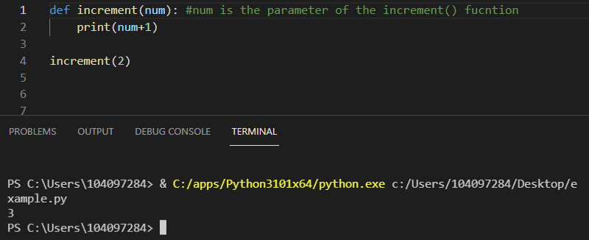

1. Using an example, describe the term **scope** as it is used in procedural programming (not in business or project management). Make sure you explain the different kinds of scope.

Scope determines which part of the program can access a variable.

* Global Scope:

* Local Scope

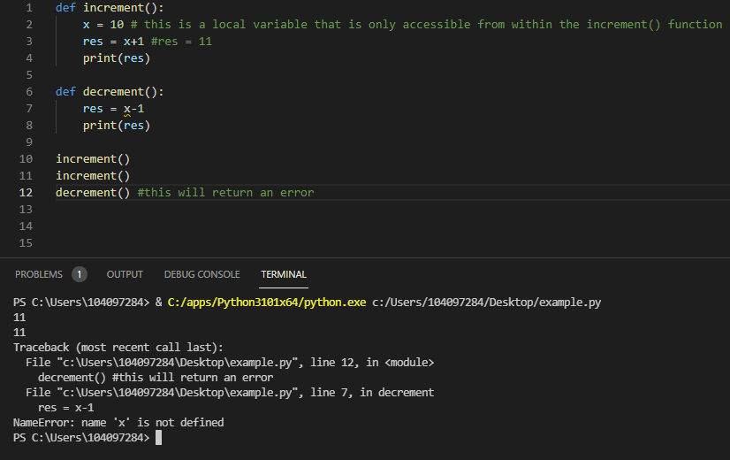

1. In a procedural style, in any language you like, write a function called Average, which accepts an array of integers and returns the average of those integers. Do not use any libraries for calculating the average. You must demonstrate appropriate use of parameters, returning and assigning values, and use of a loop. Note — just write the function at this point, we’ll *use* it in the next task. You shouldn’t have a complete program or even code that outputs anything yet at the end of this question.

(Python)

1. In the same language, write the code you would need to call that function and print out the result.

(Written in Python)

1. To the code from 9, add code to print the message “Double digits” if the average is above or equal to 10. Otherwise, print the message “Single digits”. Provide a screenshot of your program running.

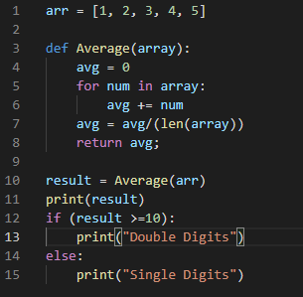(Written in Python) *=